MAIN STEPS:
Data Processing – Lower, Punctuation, Lists
Embedding/Tokenizing – Vocab, Mapping, Encode input and output
Length – Review length, outliers, padding
Main – Data Split, Model, Training, Prediction
Detailed STEPS
Step-by-step process for how Recurrent Neural Networks (RNN) can be implemented using Long Short Term Memory (LSTM) architecture:
- Load in and visualize the data
DATA PROCSESING: (Lower, Punctuation, Lists)
- Data Processing — convert to lower case
- Data Processing — Remove punctuation
- Data Processing — Create list of reviews
TOKENIZE (Vocab, Encode Input, Output)
- Tokenize — Create Vocab to Int mapping dictionary
- Tokenize — Encode the words
- Tokenize — Encode the labels
LENGTH (length, outliers, padding)
- Analyze Reviews Length
- Removing Outliers — Getting rid of extremely long or short reviews
- Padding / Truncating the remaining data
MODEL:
- Training, Validation, Test Dataset Split
- Dataloaders and Batching
- Define the LSTM Network Architecture
- Define the Model Class
- Training the Network
- Testing (on Test data and User- generated data)

EXAMPLE 1: https://stackabuse.com/python-for-nlp-movie-sentiment-analysis-using-deep-learning-in-keras/
MANY TO ONE – Sentence to Word
1 - PRE-PROCSESING:
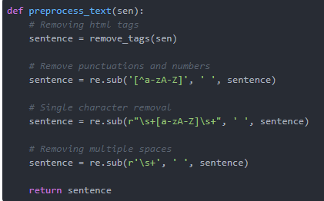
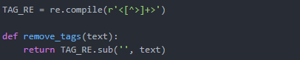
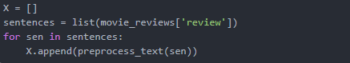

Output Y – Laben Encoding
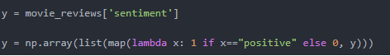

2. EMBEDDING LAYER:
Tok.text_to_sequence()
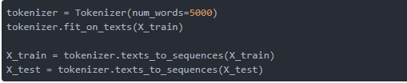
Pad_Seqeunces by maxlen (Post)
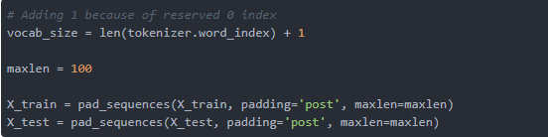
Embedding
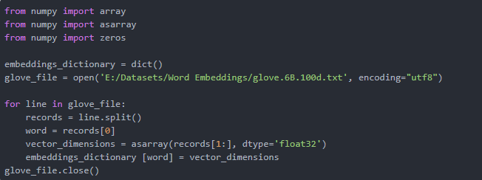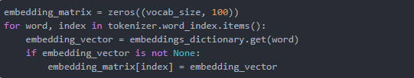
MODEL:
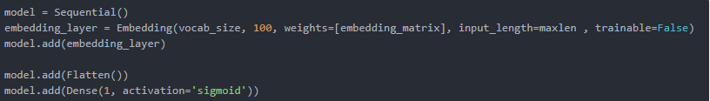

EXAMPLE 2: https://www.kaggle.com/adnanzaidi/simple-lstm-for-text-classification/edit/run/24085680
MANY TO ONE – Sentence to Word
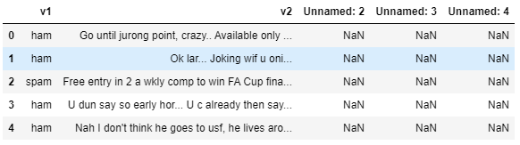
- PRE PRORCSESING:
(Nothing except the format is okay as imported)
Label Encoding output column V1 – Y as:
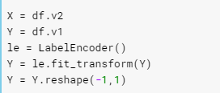
- EMBEDDING
Text to seq
Pad_Seq
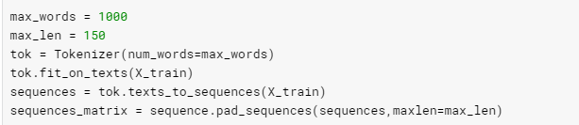
MODEL:
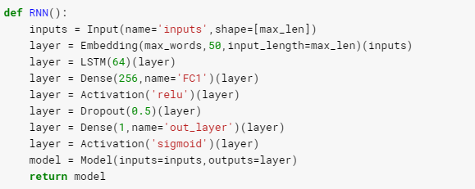

EXAMPLE 3:
https://towardsdatascience.com/recurrent-neural-networks-by-example-in-python-ffd204f99470
MANY TO MANAY – SENTENCE TO SENTENCE
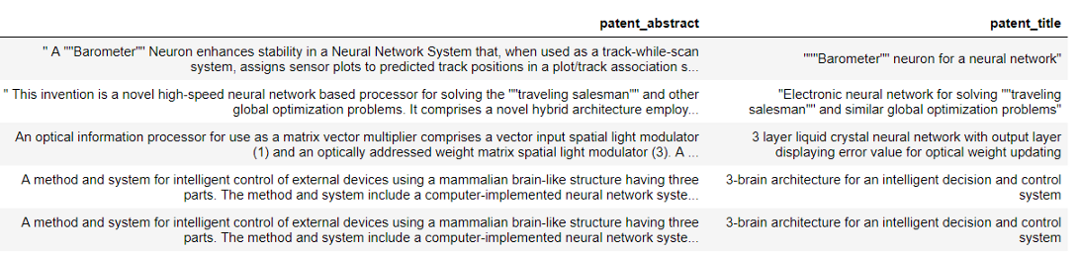

- PRE PROCSESING
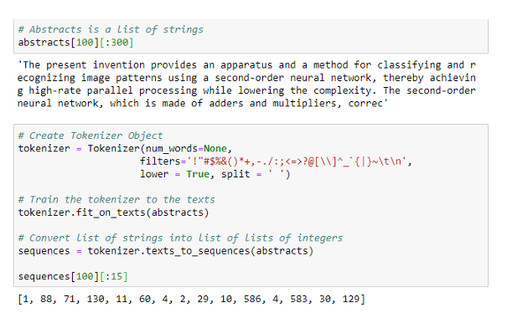
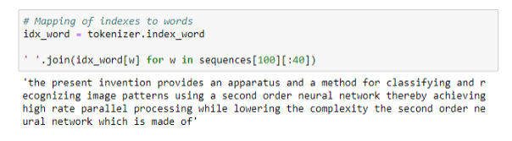
FEATURES & LABEL ENCODING
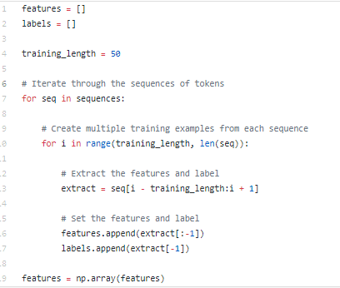
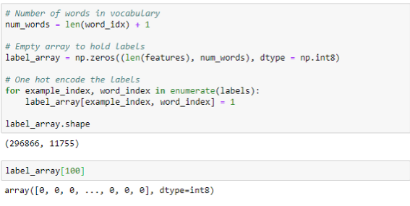
MODEL:
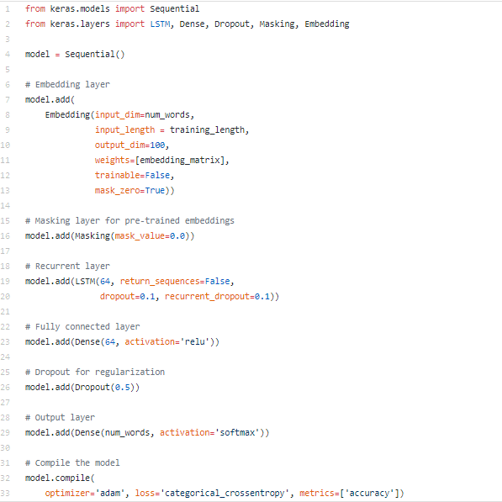

EXAMPLE 4: https://www.kaggle.com/nilanml/imdb-review-deep-model-94-89-accuracy
MANY TO ONE
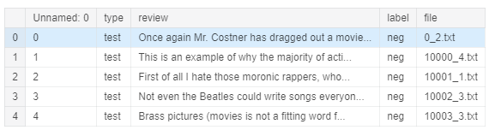

LABEL ENCODE OUTPUT
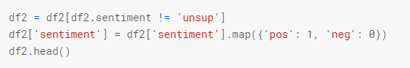

PRE PROCSESING

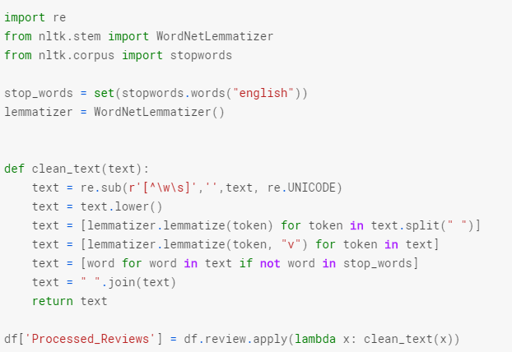
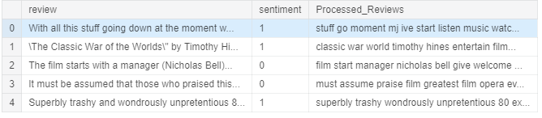
EMBEDDING :
Text to sequence
Pad_Sequences
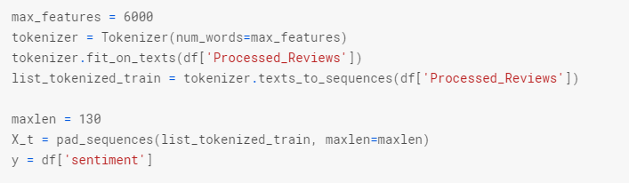

MODEL:
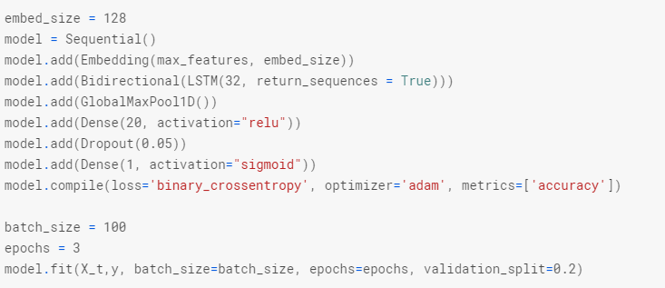

EXAMPLE-5 : https://machinelearningmastery.com/define-encoder-decoder-sequence-sequence-model-neural-machine-translation-keras/
MANY TO MANY – Machine Translation (Encoder/Decoder)
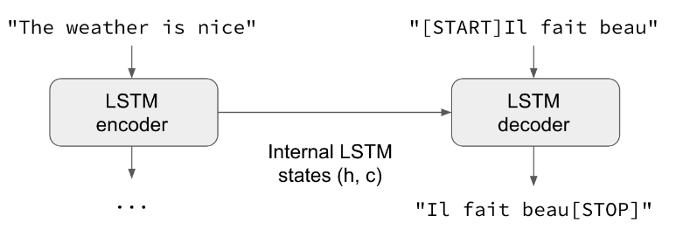
The dataset is called “Tab-delimited Bilingual Sentence Pairs” and is part of the Tatoeba Project and listed on the ManyThings.org site
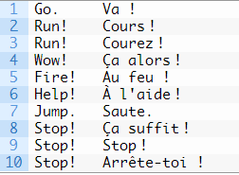
- Input Sequences: Padded to a maximum length of 16 characters with a vocabulary of 71 different characters (10000, 16, 71).
- Output Sequences: Padded to a maximum length of 59 characters with a vocabulary of 93 different characters (10000, 59, 93).
For example (with minimal padding and without one-hot encoding):
- Input1: [‘G’, ‘o’, ‘.’, ”]
- Input2: [ ”, ‘V’, ‘a’, ‘ ‘]
- Output: [‘V’, ‘a’, ‘ ‘, ‘!’]

Define Encoder:
encoder is a sequence of characters, each encoded as one-hot vectors with length of num_encoder_tokens.
LSTM layer in the encoder is defined with the return_state argument set to True
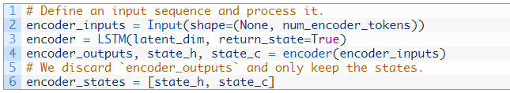

Define Decoder:

decoder input is defined as a sequence of French character one-hot encoded to binary vectors with a length of num_decoder_tokens.
LSTM layer is defined to both return sequences and state.
A Dense output layer is used to predict each character
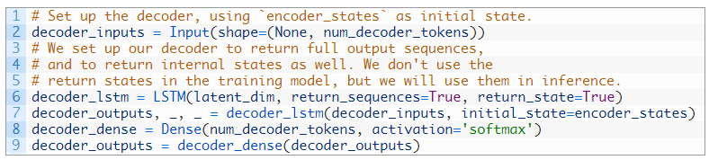

EXAMPLE 6: RNN FOR STOCK PREDICTIONS:
PREDICTION – MANY TO ONE
https://www.kaggle.com/adnanzaidi/stockprediction

